ASSIGNMENT-2

Database Systems & Web (15B11CI312)

1. [CO5]

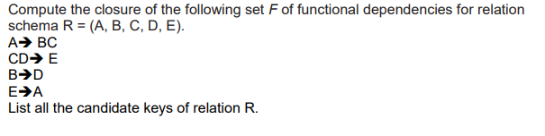

2. {CO5]

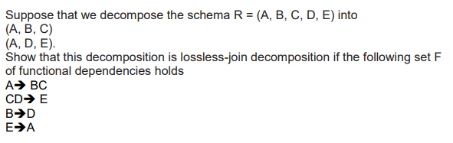

1. [CO6] Which of these schedule is serializable

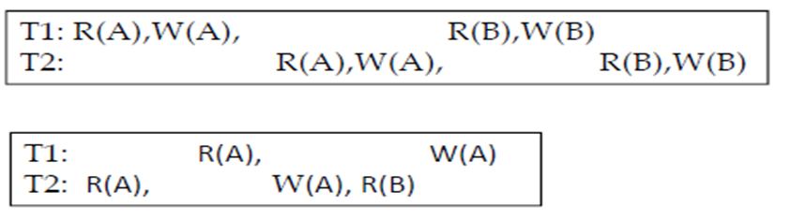

1. Consider the following two transactions:

*T*1: read(*A*);

read(*B*);

**if** *A* = 0**then** *B* := *B* + 1;

write(*B*).

*T*2: read(*B*);

read(*A*);

**if** *B* = 0**then** *A* := *A* + 1;

write(*A*).

Let the consistency requirement be *A* = 0 *∨ B* = 0, with *A* = *B* = 0 the initial values.

**a.** Show that every serial execution involving these two transactions preserves the consistency of the database.

**b.** Show a concurrent execution of *T*1 and *T*2 that produces a nonserializable schedule.

**c.** Is there a concurrent execution of *T*1 and *T*2 that produces a serializable schedule?

4. Discuss the Two-Phase Locking Protocol along with its variants (conservative, rigorous, strict). Also, state which of these can provide serializable, recoverable, cascade less, deadlock free schedules or not.